Cinema Booking System

[Company name] | [Company address]

Cinema Manager (user type)

AUTHOR NAME

2022

Contents

Table of Figures 1

Part 01: Critical Review on the modelling of Framework 2

UML Diagram 3

Part 02: Reflections on implementation of the function 6

Concurrency 6

# Table of Figures

Figure 1: Use Case Diagram for Cinema Movie Ticket Booking System 3

Figure 2: Class Diagram for Cinema Movie Ticket Booking System 4

Figure 3: UML for Movie Ticket Booking System 5

# Part 01: Critical Review on the modelling of Framework

Uweflix Cinema provides a description of a cinema seat booking system along with its architecture in this case study. The goal of the system is to make it simple for members of the public to make reservations for movie tickets, enabling them to select and reserve seats in advance for the movie of their choosing. Evaluation is a very important step in the process of developing and improving new computer interfaces.

The purpose of this investigation into the Uweflix Cinema booking system is to determine its primary objective, which is to make it possible to make purchases in advance so that new movies can be shown. Customers, including students, faculty, and staff, as well as their families, are given the ability to gain convenient access to the theater's presentations thanks to this system.

Speaking of the benefits that come with this to the customer, they can easily access and pre-book any time they want some relaxation. Time can be consumed on the Uweflix desktop, which can be helpful in showing ticket availability and in booking tickets. Uweflix Desktop also made online payment options available in order to make the payment system more user-friendly.

To translate a high-level design concept into tangible artifacts, a low-fidelity prototype is a method that is both quick and easy to implement. Because it is paper-based, it does not permit users to interact with each other. Instead of focusing on the product's outward appearance, the primary purpose of the Uweflix desktop is to check and test the functionality of the application.

low definitely prototype in clerk, a one-of-a-kind tool that can radically improve your work and help build an environment in which users' needs can be truly realised. low definitely prototype in clerk. The job of the clerk in this establishment is to display all of the information regarding the availability of movie tickets and to confirm the booking of tickets when seats become available. Everyone involved will need to spend more time and wait in order to book tickets.

Before moving forward with the production of actual goods, it is important to conduct design validation on a prototype. Your decision to test your product or not has a direct bearing on how successful it will be. If this is the very first time that something like this has been tested, there is a significant possibility that users will provide negative feedback. The Uweflix Cinema desktop system is a tool that provides assistance with the visual design, content, and interactivity of Cinema.

In the final point of comparison, we talked about how both of them make it possible for the product to experiment with a variety of different concepts without requiring an excessive amount of work. This particular form of prototypical stimulation in the context of group work. Because low fidelity does not require any particular level of skill, a greater number of people can be included in the design process. When it comes to booking tickets, using the Uweflix Cinema desktop is more advantageous than using traditional Tickets clerks.

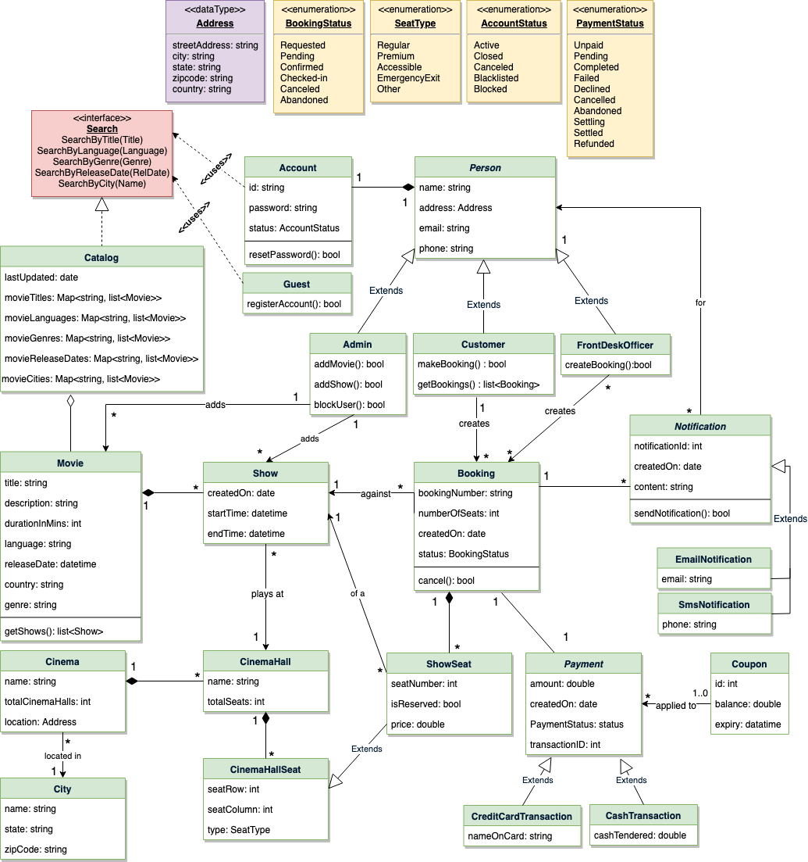

Figure : Class Diagram for Cinema Movie Ticket Booking System

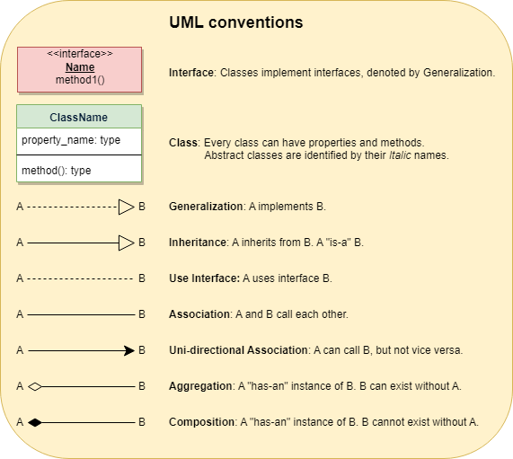

Figure : UML for Movie Ticket Booking System

# Part 02: Reflections on implementation of the function

Within this system, the five primary Actors are as follows: Admins are responsible for a variety of tasks, including the addition of new movies and their associated shows, the cancellation of any movie or show, and the blocking and unblocking of customers. The FrontDeskOfficer is authorised to book and cancel tickets. Customers are able to view movie schedules, book theatre seats, and cancel reservations at any time. Guest: Anyone who visits the site can look up movies, but in order to reserve seats, they will need to sign up as a member first. The system is primarily in charge of transmitting notifications regarding new movies, bookings, cancellations, and the like.

The following is a list of the most common applications of the Movie Ticket Booking System: Try looking up movies: You can search for movies using the title, genre, language, or release date, as well as the name of the city. Make, Modify, or View Reservations: In order to view information about a movie show, cancel an existing reservation, or book a new one, click here. Make a payment for the reservation: to make the payment for the reservation. Include a discount coupon in your payment: to apply a discount coupon to the total cost of the purchase. Customers will be presented with a seating chart in order to give them the opportunity to select specific seats for their reservation. Customers who cancel their subscriptions will have the amount of their payments refunded to them upon cancellation, provided that the cancellation is processed within the allotted window of time.

## Concurrency

How can concurrency be managed in a way that prevents multiple users from making reservations for the same seat? When working with SQL databases, we can avoid any potential conflicts by using transactions. For instance, if we are going to be updating some rows in SQL server, we can use something called Transaction Isolation Levels to lock those rows first. Note that if we read rows while we are in the middle of a transaction, a write lock will be placed on those rows, preventing any other users from editing them.

The most secure level of isolation is called "Serializable," and it protects users from Dirty, Nonrepeatable, and Phantoms reads. It is safe to assume that the reservation has been marked successfully once the database transaction described above completes successfully. This will ensure that no two customers will be able to make reservations for the same seat.